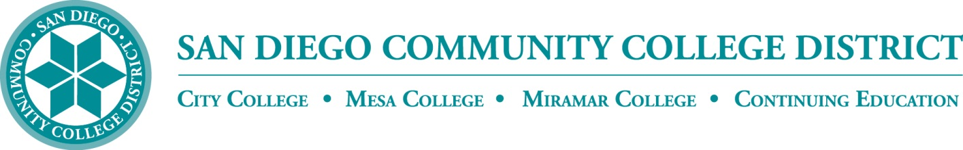**BP 4400**

**Board Policy**

Chapter 4 – Academic Affairs

**BP 4400 COMMUNITY SERVICE CLASSES**

**Reference:**

Education Code Section 78300

The ~~San Diego Community College~~ District’s Colleges and Continuing Education may develop and offer community service classes in fields including but not limited to civic, vocational, literacy, health, technical and general education, music, art, handicraft, science, literature, nature study, aquatic sports and athletics.

The community service classes shall be designed to contribute to the physical, mental, moral, economic, or civic development of the individuals enrolled in it. Community service classes shall be open for admission of individuals who can benefit from the classes.

No General Fund monies may be expended to establish or maintain community service classes. Students involved in community service classes shall be charged a fee not to exceed the cost of maintaining the classes. Classes may also be offered ~~by~~ for remuneration by contract or with contributions or donations ~~of~~ from individuals or groups.

~~References:~~

~~Education Code Section 78300~~

~~Adopted: 7/7/11~~

~~Supersedes : New Policy~~

|  |  |
| --- | --- |
| **Adopted:** July 7, 2011  **Revised:** |  |
| *(Replaces current SDCCD BP 5400)* |  |

**Legal Citation for BP 4400**

#### EDUCATION CODE - EDC

#### TITLE 3. POSTSECONDARY EDUCATION [66000 - 101060]

*( Title 3 enacted by Stats. 1976, Ch. 1010. )*

#### DIVISION 7. COMMUNITY COLLEGES [70900 - 88810]

*( Division 7 enacted by Stats. 1976, Ch. 1010. )*

#### PART 48. COMMUNITY COLLEGES, EDUCATION PROGRAMS [78015 - 79420]

*( Part 48 enacted by Stats. 1976, Ch. 1010. )*

#### CHAPTER 2. Courses of Study [78210 - 78300]

*( Chapter 2 enacted by Stats. 1976, Ch. 1010. )*

##### ARTICLE 7. Community Service Classes [78300- 78300.]

*( Article 7 enacted by Stats. 1976, Ch. 1010. )*

###### 78300.

(a) The governing board of any community college district may, without the approval of the Board of Governors of the California Community Colleges, establish and maintain community service classes in civic, vocational, literacy, health, homemaking, technical and general education, including, but not limited to, classes in the fields of visual and performing arts, handicraft, science, literature, nature study, nature contacting, aquatic sports and athletics. These classes shall be designed to provide instruction and to contribute to the physical, mental, moral, economic, or civic development of the individuals or groups enrolled therein.

(b) Community service classes shall be open for the admission of adults and of those minors as in the judgment of the governing board may profit therefrom.

(c) Governing boards shall not expend General Fund moneys to establish and maintain community service classes. Governing boards may charge students enrolled in community service classes a fee not to exceed the cost of maintaining community service classes, or may provide instruction in community service classes for remuneration by contract, or with contributions or donations of individuals or groups. The board of governors shall adopt guidelines defining the acceptable reimbursable costs for which a fee may be charged and shall collect data and maintain uniform accounting procedures to ensure that General Fund moneys are not used for community services classes.

*(Amended by Stats. 2001, Ch. 734, Sec. 68. Effective October 11, 2001.)*